**REGION 11**

**ΚΑΡΑΪΒΙΚΗ**

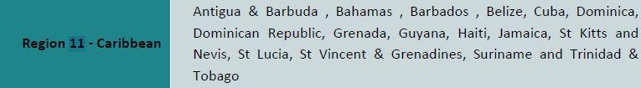

|  |  |  |  |
| --- | --- | --- | --- |
| **Α/Α** | **ΧΩΡΑ** | **ΠΑΝΕΠΙΣΤΗΜΙΟ** | **ΣΥΝΤΟΝΙΣΤΗΣ** |
|  |  |  |  |
|  |  |  |  |
|  |  |  |  |
|  |  |  |  |
|  |  |  |  |
|  |  |  |  |
|  |  |  |  |