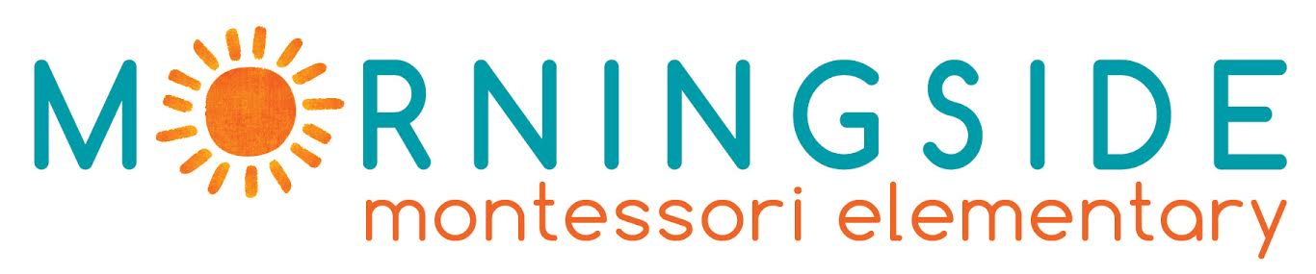

INTERNSHIP VACANCY

EMPLOYER INFORMATION
Name of the Organization | Morningside Montessori Elementary Private School
Address | Dorieon 20, Ayios Andreas
Postal Code | 1101
City | Nicosia , Cyprus
Telephone | +35799319536
Facebook page  Website | https://www.facebook.com/MorningsideCyprus/  http://www.morningsidemontessori.com.cy/en/home
Morningside at a Glance | Morningside Montessori is the first elementary in Cyprus to follow the Montessori Method. Our learning environment, which is not bound within the classroom, is hands-on and child-directed. We aim to educate the whole child through a comprehensive Montessori education that cultivates outdoor learning, self-directed action, flexible thinking, creativity, and non-standardized models of problem-solving.  We believe that we must embrace each other with empathy, in order to promote a culture of peace and understanding. It is for this reason that it is imperative to learn and understand each other’s language. The main language of instruction at th school is English, although Greek and Turkish are also taught.

CONTACT DETAILS
Contact Person (s) | Evi Eftychiou
Title | Board Director
Direct Telephone Number | +35799319536
Direct Email Address | evi@morningsidecyprus.com

PLACEMENT INFORMATION
Description of Activities | Teacher Assistant / Summer school teacher assistant  - Assist in tasks related with the daily operation of the school  - Organize, coordinate and participate in the educational activities  - Assist in the preparation of educational material  - Co-teaching on various subjects  - Assist in fundraising activities, festivals and events to be organized by the school
Skills and Personal Qualities | -creative flair  - strong organizational skills  -originality  -strong computer skills  -confidence, to present and explain ideas  -the ability to balance work on several projects at a time  -flexibility
Duration | Minimum 2 months – max 12 months
Period | 2023-2024
Working Hours | Approximately 30-40 hours per week
Help with finding Accommodation | - YES (we can provide a list with possible flats or rooms for rent)
Offered | - Accidents insurance 24 hours coverage (in and out of the workplace)  - Paid liability insurance  - During working days the school will provide to the intern student breakfast and lunch

REQUIREMENTS
Excellent English language skills | Candidate must be able to communicate in English.  Knowledge of Greek or Turkish will be considered an asset.
Eligible to apply | Graduate Students  Students with Bachelor degree in:  - Education (preferred)  - Social Sciences and Humanities  - Arts  - Sciences  Priority will be given to candidates who study Education related subjects.
Required Documents | -CV  -Motivational Letter /email
Please send your relevant document in this email: evi@morningsidecyprus.com
Deadline: open

