ARRIVAL TO KAUNAS

Kaunas is the second-largest city in Lithuania, situated in the centre of the country. It’s also at the confluence of Lithuania’s two biggest rivers! Here are the most convenient ways of travelling to Kaunas and getting around the city.

Travelling in Kaunas
By plane

Wizz Air, Ryanair as well as some charter flight companies, fly to and from Kaunas international airport. It is located in the central part of the country, 14 km northeast of the Kaunas city centre and 100 km west of the capital Vilnius. Hop in the city bus #29G (its timetable is adjusted to the arrivals schedule) to reach the city centre for the most affordable price – 1 Eur! Here's a simple scheme we've prepared for you to decide where to get off the bus.
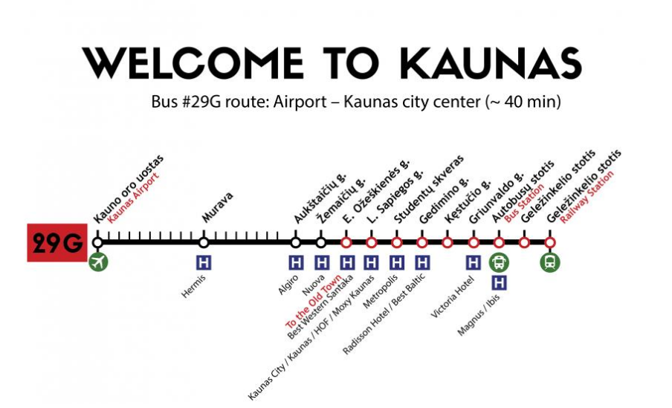
Of course, you can also call a cab (we recommend the Bolt app).

Getting around Kaunas
Public transport
Kaunas is a very walkable city; we suggest you pack your most comfortable shoes. To reach objects in the outskirts of the city (or if it rains, or if you happen to love buses and trolleybuses!), we suggest you use the busy network of public transport. Download the Trafi app for real-time traffic and timetables and Žiogas app for purchasing (cheaper) tickets. The latter is super-fast and convenient! There's also a public transport network website called stops.lt that quite possibly speaks your language, too.

Taxi and car sharing
Uber does not operate in Kaunas as of April 2019, but there’s a similar service called Bolt. Here’s a discount code for first-time users – KAUNASIN. Enter it when registering the app and save 7 Eur! You can also ask your hotel staff to call you a cab by phone.
CityBee car-sharing app offers plenty of new (or new-ish) cars that you can pick up and drop off in dozens of places around the city. You can also get an electric vehicle from Spark in Vilnius and park/charge it in Kaunas.
Scooters
Bolt launched the scooter-sharing service in the central part of Kaunas in August 2019. Fun times! Simply download the app or use the same one you use for calling a cab or ordering food.

Also, to get to Kauno kolegija / Higher Education Institution you should choose 16 trolleybus or buses: 27G, 57G if you go from station named Studentų skveras.
If you go from station named Gedimino g. you can choose 8 or 9 trolleybus.
If you go from station named L. Sapiegos g. you can choose 9 trolleybus.

