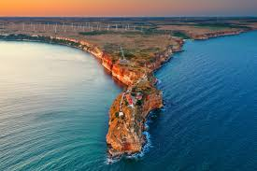

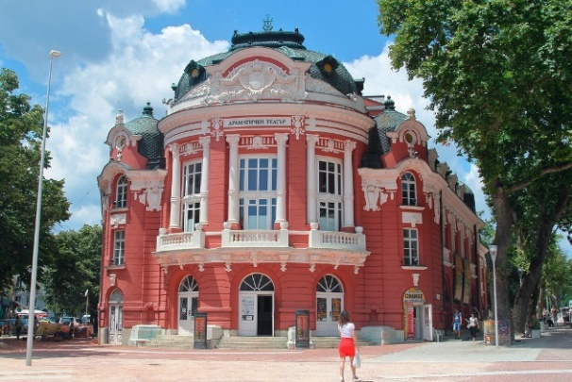
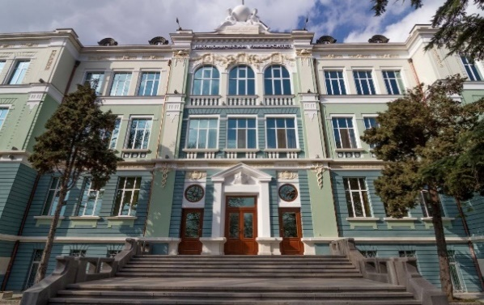

3-7 July 2023
3rd International Staff Week

University of Economics – Varna
(BG VARNA04)
”Enriching Mobility Experience”

Monday  3rd July | 09:30 – 10:00 | Registration of participants/Main building, floor 1, Conference hall 1
 | 10:00 – 11:00 | Opening session and Presentation of UE-Varna
 | 11:00 – 12:00 | Campus tour
 | 12:00 – 13:15 | Lunch in Red Canape restaurant (provided by UE-Varna)
 | 13:30 - 14:30 | Campus competition game/Main building, floor 1, Conference hall 1
 | 14:30 – 14:45 | Coffee break (provided by UE-Varna)
 | 14:45 – 16:00 | Getting to know each other activities/Main building, floor 1, Conference hall 1

Tuesday  4th July | 08:40 | Group photo/University yard
 | 09:00 – 10:15 | Crash Course in Bulgarian Language/Main building, floor 1, Conference hall 1
 | 10:15 – 10:30 | Coffee break (provided by UE-Varna)
 | 10:30 – 12:00 | Who is who: Presentations of participant home institutions/Main building, floor 1, Conference hall 1
 | 12:00 – 13:15 | Lunch break
 | 13:30 | Free time/ Optional Varna Highlights Walking Tour (provided by UE-Varna)
 | 19:00 | Dinner at Ivanchov Han restaurant (provided by UE-Varna)

Wednesday  5th July | 10:00 – 12:00 | Workshop: The Ideal Orientation Week for Exchange Students /Main building, floor 1, Conference hall 1
 | 10:45 – 11:00 | Coffee break (provided by UE-Varna)
 | 12:00 | Lunchbreak and free time

Thursday  6th July | 10:00 – 12:00 | Workshop: GO GREEN/Main building, floor 1, Conference hall 1
 | 10:45 – 11:00 | Coffee break (provided by UE-Varna)
 | 12:00 – 13:15 | Lunchbreak
 | 13:30 | Trip to Aladzha monastery and the legendary cape Kaliakra

Friday  7th July | 09:00 | Transfer to Old Varna museum/university yard
 | 09:30 – 11:00 | The History of Varna and Its Viticulture Traditions. Wine Tasting (provided by UE-Varna)
 | 11:00 – 12:00 | Closing session and Certificate ceremony
 |  | Departure

Workshops

Monday, 3rd July, 15:15
Getting to Know Each Other
Main building, floor 1, Conference hall 1
Moderator: IRO, UE-Varna
-------------------------------------------------------------------------------------------------

Tuesday, 4th July, 09:00
Crash Course in Bulgarian Language
Main building, floor 1, Conference hall 1
Moderator: IRO, UE-Varna
--------------------------------------------------------------------------------------------------

Wednesday, 5th July, 10:00
Workshop: The Ideal Orientation Week for Incoming Exchange Students
Main building, floor 1, Conference hall 1
Moderator: Nevena Dobreva, PhD, Chairwoman of Foundation for
Entrepreunership, Culture and Education

----------------------------------------------------------------------------------------------------

Thursday, 6th July, 10:00
Workshop: GO GREEN (how to make your university more sustainable and inclusive)
Main building, floor 1, Conference hall 1
Moderators: UE-Varna PhD students

