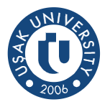
Usak University 3rd International Staff Week
“Re-connection in New Era”
6th June-10th June 2021

Personal Data
Name & Surname
Gender
Name of University
Faculty
E-mail
ERASMUS CODE
Staff Mobility for Teaching or Training
Area of Interest:
Specify if necessary.

I hereby declare my willingness to participate in the 3rd International Staff Week organized face-to-face by Uşak University.

Signed: Date: 01/01/2022

P.S. Please return this application form by e-mail to erasmus@usak.edu.tr

